## INTERNSHIP REPORT

*This Internship report is submitted to*

**St. Vincent Pallotti College of Engineering & Technology** (An Autonomous Institution Affiliated to Rashtrasant Tukadoji Maharaj Nagpur University, Nagpur)

***In partial fulfillment of the requirements for the award of the degree of Bachelor of Technology in***

**COMPUTER ENGINEERING**

***Submitted by***

**MADHAVI BINIWALE**

**Under the supervision of**

**PROF. VAIBHAV V. DESHPANDE**

Assistant Professor

**in**

Clustor Computing, Nagpur

&

Cognizant Technology Solutions, Chennai

#### Academic Year 2024-25



**Department of Computer Engineering**

# ST. VINCENT PALLOTTI

**COLLEGE OF ENGINEERING AND TECHNOLOGY**

##### Gavsi Manapur, Wardha Road, Nagpur -441108

CERTIFICATE

This is to certify that the “**Internship report”** submitted by **MADHAVI BINIWALE (21001122)** is work done by her and submitted during 2024-2025 academic year, in partial fulfilment of the requirements for the award of the degree of **BACHELOR OF TECHNOLOGY in Computer Engineering,** at **St. Vincent Pallotti College of Engineering & Technology, Nagpur.**

**Prof. Vaibhav V Deshpande Dr. Reema Roychaudhary**

**Assistant Professor Assistant Professor**

**Department Mentor Internship Coordinator**

**Dr. Sunil Wanjari Dr. Vijay Wadhai**

**Associate Professor Principal**

**Head of the Department**



**Department of Computer Engineering**

**ST. VINCENT PALLOTTI**

**COLLEGE OF ENGINEERING AND TECHNOLOGY**

Gavsi Manapur, Wardha Road, Nagpur – 441108

(An Autonomous Institute affiliated to RTMNU, Nagpur)

**ORGANIZATION CERTIFICATE**

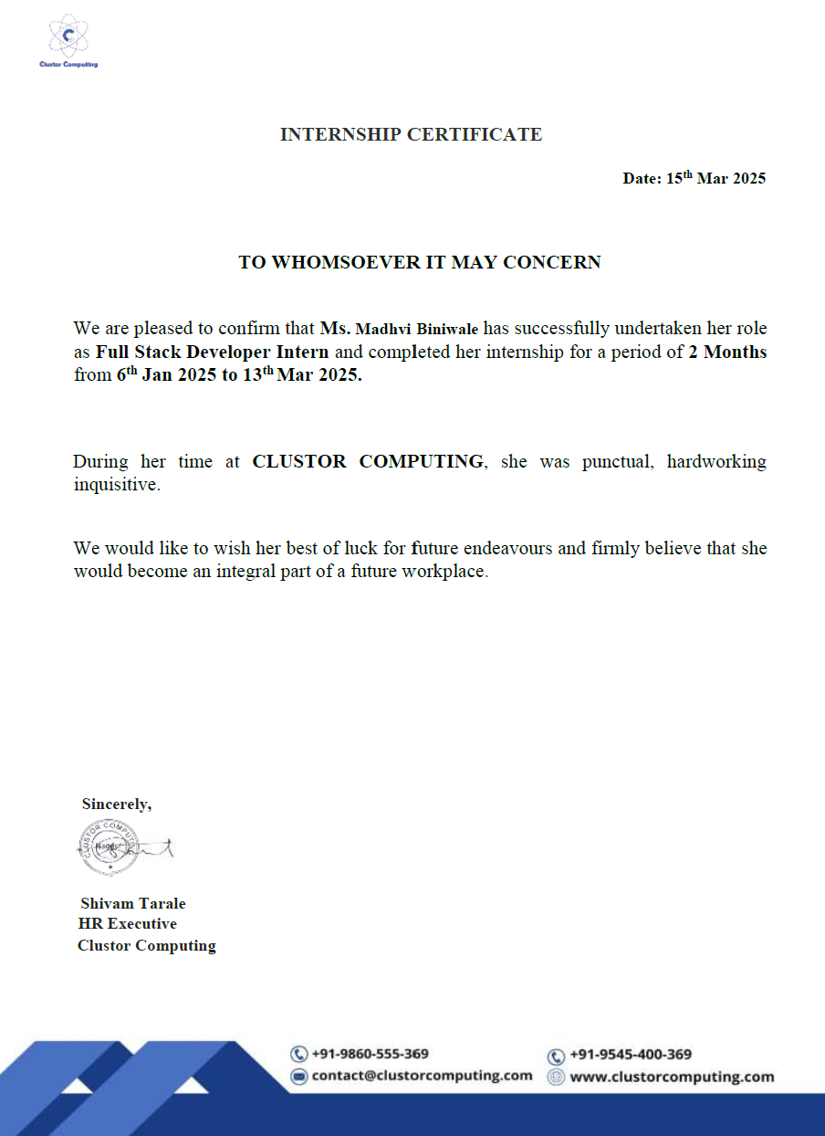

## ACKNOWLEDGEMENT

This Internship work is one of the major milestones in my journey of learning. I would like to sincerely thank **Shivam Tarale, HR, Clustor Computing** and **Sivakumar Nivarthi, Senior Manager, Cognizant Technology Solution** for her/his guidance at every stage of the internship and for her/his prompt and insightful input.

I would like to thank **Dr. Sunil M. Wanjari, Head, Department of Computer Engineering** and all our faculty members who reviewed my work and pointed out the shortcomings, their valuable insights and recommendations propelled my internship work forward, helping me overcome challenges and complexities along the way.

I am especially thankful to our **departmental mentor, Prof. Vaibhav V. Deshpande**, for his/her dedicated mentorship and consistent support throughout the course of the internship. His/her guidance was instrumental in shaping my approach and ensuring meaningful progress.

Also, I am very grateful to the Institute **Principal Dr. Vijay M. Wadhai and Management,** for their support facilities provided during the internship.

**Madhavi S. Biniwale**

**ABSTRACT**

Over the course of a 18-week internship, I had the opportunity to work with two organizations Clustor Computing and Cognizant Technology Solutions each offering unique learning experiences that broadened my technical and professional skills. This internship provided me with an enriching opportunity to apply and expand my academic knowledge in full-stack development and SAP in a practical environment.

At Clustor Computing, I explored the world of web development through two engaging projects. The first involved creating a personal portfolio website, where I learned how to design and present my skills and achievements in a clean, interactive format. The second project was a text-to-speech converter, which allowed me to experiment with browser-based functionalities and focus on user accessibility. These experiences helped me strengthen my front-end development skills and sparked a deeper interest in building user-friendly applications.

Later, at Cognizant Technology Solutions, I underwent structured training in the SAP Sales and Distribution (SAP SD) domain. This phase introduced me to enterprise-level software systems and gave me hands-on exposure to how key business processes such as sales, billing, and customer relationship management are handled within the SAP ecosystem.

Overall, the experience helped me bridge the gap between classroom learning and real-world application, boosting my confidence and better preparing me to take on future challenges in the tech industry.

**TABLE OF CONTENTS**

|  |  |  |
| --- | --- | --- |
| **CHAPTER NO.** | **TITLE** | **PAGE NO.** |
|  | **LIST OF FIGURES** | **I** |
| **1** | **INTRODUCTION** | **1** |
| **2** | **COMPANY/ORGANIZATION**  2.1 Clustor Computing  2.2 Cognizant Technology Solutions | **2**  2  3 |
| **3** | **INTERNSHIP OBJECTIVES** | **4** |
| **4** | **TECHNOLOGIES USED**  4.1 Technologies Used at Clustor Computing  4.1.1 Programming Languages  4.1.2 Application programming interface  4.1.3 Tools  4.2 Technologies Used at Cognizant  4.2.1 SAP Tools | **6**  6  6  6  7  7  7 |
| **5** | **MODULES DEVELOPED / TASKS PERFORMED**   * 1. Personal Portfolio Website   2. Text-to-Speech Converter   5.6 SAP SD process | **8**  8  8  9 |
| **6** | **WEEKLY OVERVIEW OF INTERNSHIP ACTIVITIES** | **11** |
| **7** | **LEARNING OUTCOMES** | **15** |
| **8** | **CHALLENGES FACED AND SOLUTIONS** | **17** |
| **9** | **CONCLUSION** | **18** |
|  | **BIBLIOGRAPHY / REFERENCES** | **19** |
|  | **ANNEXURES** | **20** |

**LIST OF FIGURES**

|  |  |  |
| --- | --- | --- |
| **FIGURE NO** | **FIGURE NAME** | **PAGE NO** |
| 1 | Personal Portfolio Website | 20 |
| 2 | The build log | 20 |
| 3 | Text-to-Speech Converter | 21 |
| 4 | Customer Creation | 21 |
| 5 | Material Creation | 22 |

**I**

**CHAPTER 1**

**INTRODUCTION**

**CHAPTER 1**

**INTRODUCTION**

As a part of my academic journey, I had the opportunity to intern at two distinguished companies based in Nagpur. For the initial phase, I worked at **Clustor Computing**, where I engaged in practical web development projects. I created a personal portfolio website to showcase my skills and achievements, focusing on responsive design and user-friendly layout. Another notable project was a text-to-speech converter, where I implemented browser-based speech synthesis features to enhance accessibility. These tasks helped me strengthen my understanding of front-end technologies and improve my design and problem-solving abilities.

In the following phase, I joined **Cognizant Technology Solutions**, where I received comprehensive training in the SAP Sales and Distribution (SD) domain. SAP SD is a key module in the SAP ERP system that handles all processes related to order processing, shipping, billing, and customer relationship management. During the training, I learned how to configure and manage components such as customer master data, material master data, pricing conditions, sales documents, and delivery processes. I also explored the integration of SD with other modules like MM (Materials Management) and FI (Financial Accounting), which deepened my understanding of how cross-functional business operations are managed within an ERP system. Through hands-on exercises, real-time case studies, and simulation-based learning, I gained valuable insights into how businesses use SAP to streamline their sales cycle, improve accuracy, and enhance customer service.

During this internship, I was exposed to a wide range of tools and concepts in web development and SAP, which enabled me to apply my academic learning to real-world scenarios and develop skills essential for a career in the IT industry.

1

**CHAPTER 2**

**COMPANY/ORGANIZATION PROFILE**

**CHAPTER 2**

**COMPANY/ ORGANIZATION PROFILE**

**2.1 Clustor Computing**

Clustor Computing is an IT startup located in Nagpur, specializing in digital transformation and intelligent automation solutions. The company leverages advanced methods in business intelligence and artificial intelligence to modernize industries and automate systems. Clustor offers next-generation services, including cloud computing, big data, IoT, mobile internet, and AI-driven tools for marketing, design, communication, and business modeling.

With a team size of around 11–50 professionals, Clustor serves clients from various domains such as fintech, healthcare, software, and more. The company creates scalable solutions that help businesses become more connected, data-driven, and efficient. Their focus on research and development enables them to provide customized and innovative solutions tailored to clients' needs. The company’s strong commitment to emerging technologies like machine learning, deep learning, and natural language processing (NLP) further solidifies their position in the tech landscape.

Clustor Computing is known for its agility and responsiveness, adapting quickly to market trends and customer requirements. They place a high emphasis on fostering a collaborative work environment, where teams work closely on solving complex problems. The company maintains strong client relationships by providing continuous support and ensuring the scalability and sustainability of the solutions offered.

Clustor Computing is also focused on sustainability, exploring eco-friendly technologies and practices that reduce environmental impact while improving efficiency. Their overarching goal is to help businesses embrace digital transformation, making them more efficient, sustainable, and data-driven.

2

**2.2 Cognizant Technology Solution**

Cognizant is a multinational IT services and consulting company headquartered in Teaneck, New Jersey, USA. Established in 1994 as a technology division of Dun & Bradstreet, it became an independent company in 1996. Cognizant is a leading provider of digital, technology, consulting, and operations services, and has grown to become one of the largest IT services companies in the world.

Cognizant specializes in delivering end-to-end services across various industries, including financial services, healthcare, manufacturing, retail, and communications. Their expertise spans across digital transformation, cloud computing, artificial intelligence (AI), data analytics, enterprise solutions, and IT infrastructure management. The company provides solutions in software development, system integration, IT consulting, and business process outsourcing (BPO).

Cognizant’s clients range from Fortune 500 companies to startups, and they are known for building long-term relationships with clients by delivering high-quality, scalable solutions. The company has a strong global presence, with operations across North America, Europe, Asia, and Latin America.

The company is also recognized for its focus on employee development and training, creating a work culture that encourages innovation, diversity, and continuous learning. Cognizant's commitment to innovation is reflected in its continuous investment in emerging technologies such as blockchain, IoT, and cybersecurity.

333

**CHAPTER 3**

**INTERNSHIP OBJECTIVES**

**CHAPTER 3**

**INTERNSHIP OBJECTIVES**

* **Apply Academic Knowledge in Real-World Scenarios:** To translate classroom learning in web development, artificial intelligence, and enterprise systems into practical skills by working on industry-relevant projects and use cases.
* **Gain Practical Web Development Experience:** To design, build, and deploy interactive web applications such as a personal portfolio site and a text-to-speech converter, strengthening front-end development abilities using modern tools and practices.
* **Enhance Problem-Solving and Creativity:** To tackle real-world challenges through coding and project work, improving logical thinking, design skills, and the ability to develop efficient, user-friendly solutions.
* **Develop Basic Understanding of AI Integration:** To explore how AI functionalities like text-to-speech and voice recognition can be integrated into web apps, thereby enhancing interactivity and accessibility.
* **Receive In-Depth ERP Training in SAP SD**: To understand the SAP Sales and Distribution module in detail, including sales order processing, pricing, billing, customer data management, and delivery processes.
* **Understand End-to-End Business Process Management:** To gain insight into how business workflows from sales to invoice generation are managed and automated within an ERP system like SAP.
* **Explore SAP SD Integration with Other Modules:** To study the interaction of SD with other modules like MM (Materials Management) and FI (Financial Accounting), gaining a complete view of organizational data flow and system-wide coherence.
* **Build Technical Proficiency in Industry Tools:** To get hands-on experience with tools and platforms such as HTML, CSS, JavaScript, Python, and SAP GUI, enhancing both development and enterprise software skills.

4

* **Improve Communication and Team Collaboration Skills:** To work collaboratively with mentors and peers, participate in discussions, and present project outcomes effectively, contributing to team-based problem-solving.
* **Gain Exposure to Corporate Work Culture:** To experience a professional work environment, understand expectations, workflows, and ethics in a corporate setting, and adapt to the standards of the IT industry.
* **Strengthen Adaptability and Learning Mindset:** To become comfortable working in different domains (development and enterprise systems), and quickly learn new tools, concepts, and practices required for each.

5

**CHAPTER 4**

**TECHNOLOGIES USED**

**CHAPTER 4**

**TECHNOLOGIES USED**

During the internship, I worked with a variety of technologies spanning front-end development, interactive web design, and enterprise software systems. In the first phase at **Clustor Computing**, my focus was on building user-facing applications. I developed a personal portfolio website and a text-to-speech converter using **HTML**, **CSS**, and **JavaScript**. The text-to-speech tool integrated browser-based speech synthesis APIs, enhancing the application's accessibility and interactivity. This phase deepened my understanding of responsive layouts, modern design principles, and real-time browser functionality.

In the second phase at **Cognizant Technology Solutions**, I received structured training in the **SAP Sales and Distribution (SD)** module. I learned to navigate the **SAP GUI**, configure sales-related processes, and understand how key modules like **MM** (Materials Management) and **FI** (Financial Accounting) integrate within the ERP system. This hands-on experience gave me valuable insights into how large enterprises manage end-to-end business workflows through SAP.

**4.1 Technologies used at Clustor Computing:**

**4.1.1 Programming Languages**

* **HTML** – Used to structure the content and layout of web pages for the portfolio and text-to-speech projects.
* **CSS** – Applied to style the web pages and ensure responsive and visually appealing design across devices.
* **JavaScript** – Used to add interactivity and dynamic behavior to the applications, including API integration.

**4.1.2 Application programming interface**

* **Web Speech API (Speech Synthesis)** – A browser-based API used in the text-to-speech converter to enable speech output functionality directly from the browser.

6

**4.1.3 Tools**

* **Visual Studio Code (VS Code)** – A lightweight and versatile source-code editor used throughout the development phase.
* **Git & GitHub** – Employed for version control and collaborative project tracking during the web development phase.

**4.2 Technologies used at Cognizant Technology Solution:**

**4.2.1 SAP tool**

* **SAP GUI** – The interface used to interact with SAP ERP modules including SD, MM, and FI.
* **SAP SD Module** – Hands-on experience in sales order processing, billing, and customer management.
* **MS Excel** – Used for maintaining and analyzing master data, order tracking, and process simulations in SAP training.

7

**CHAPTER 5**

**MODULES DEVELOPED / TASKS**

**PERFORMED**

**CHAPTER 5**

**MODULES DEVELOPED / TASKS PERFORMED**

During my internship, I worked on a variety of technical modules that involved front-end web development, browser API integration, and enterprise resource planning (ERP) system training. These experiences allowed me to apply my theoretical knowledge in real-world scenarios and enhanced my understanding of how technology drives business and user-oriented solutions.

* 1. **Personal Portfolio Website:**

As a foundational project, I developed a responsive personal portfolio using HTML, CSS, and JavaScript. The website featured sections like About Me, Projects, and Contact, with a clean UI and mobile-friendly design. This task helped me understand front-end design principles, navigation flow, and the importance of visual structure in personal branding.

* 1. **Text-to-Speech Converter:**

In this project, I built a browser-based Text-to-Speech Converter using JavaScript and the Web Speech API. The tool allowed users to input text and hear it read aloud using synthesized speech. I implemented features such as voice selection and playback controls. This enhanced my understanding of browser APIs, DOM manipulation, and accessibility-focused web applications.

* 1. **SAP SD Process:**

During the second phase of my internship at Cognizant Technology Solutions, I underwent in-depth, hands-on training in the SAP Sales and Distribution (SD) module. This phase introduced me to real-time enterprise operations and helped me understand the role of ERP systems in streamlining complex business workflows. Through this experience, I gained comprehensive insight into how large organizations manage customer relationships, sales cycles, and logistics using SAP.Over the course of the training, I worked with several critical components of the SD module, including:

8

1. **Customer Master Creation:**

I learned to create and maintain customer master records, which include general data (e.g., name, address), company code data (e.g., payment terms), and sales area data (e.g., shipping conditions, pricing group). Understanding how to structure this data is essential for executing accurate and efficient sales transactions.

1. **Material Master Creation:**

I worked on defining material master data that includes essential information like material type, units of measure, pricing details, and stock availability. These records are shared across various departments such as Sales, Inventory, and Procurement, ensuring consistency and integration within the system.

1. **Pricing Procedure Configuration:**

I gained exposure to the condition technique, which is the backbone of SAP pricing. This involved configuring condition tables, access sequences, condition types, and pricing procedures. I practiced setting up custom pricing rules to reflect real-world scenarios like discounts, surcharges, and freight costs.

1. **Order-to-Cash (O2C) Process:**

I followed the complete O2C lifecycle, starting from inquiry and quotation to sales order creation, delivery processing, billing, and payment receipt. This process illustrated how different SAP modules like SD, MM, and FI work together to support an end-to-end business transaction.

1. **Contracts and Consignment Process:**

I explored long-term sales agreements such as quantity and value contracts, which allow predefined sales terms over a certain period. In consignment processes, I learned how goods are stored at the customer's site but remain the seller’s property until consumed, making inventory and billing more flexible and efficient.

1. **Free Goods Management:**

I configured scenarios for both inclusive and exclusive free goods determination. These involved setting rules where additional products are delivered for free based on quantity thresholds, customer groups, or promotional campaigns, helping to simulate real-world marketing strategies.

9

1. **Third-Party Order Processing:**

This involved creating sales orders that automatically trigger a purchase requisition to an external vendor. I studied how the goods are shipped directly from the vendor to the customer, and how the billing process is managed through inter-company transactions. It demonstrated how SAP facilitates seamless coordination between the sales team, procurement department, and external suppliers.

10

**CHAPTER 6**

**WEEKLY OVERVIEW OF INTERNSHIP ACTIVITIES**

**CHAPTER 6**

**WEEKLY OVERVIEW OF INTERNSHIP ACTIVITIES**

This chapter presents a detailed weekly account of tasks completed, technologies explored, and skills acquired throughout the 18-week internship. It highlights the learning curve from training to full-fledged project development.

**Week 1:**

I worked on basic frontend design using HTML and CSS to build static layouts for sample websites. I learned structuring web pages using elements like division, forms, headers, and footers. This helped me understand the basics of webpage styling and responsiveness. We were given a task to make the portfolio website.

**Week 2:**

During this week, I focused on enhancing my JavaScript skills and exploring browser-based APIs. I was introduced to the Web Speech API, particularly the Speech Synthesis interface, which enables text-to-speech functionality in modern browsers. To apply this, we were given a task to build a small project, and I developed a Text-to-Speech Converter. The application allows users to input any text, select from available system voices, and listen to the spoken output directly in the browser. This project helped me understand how browser APIs interact with user input and the DOM, and also improved my knowledge of user accessibility features.

**Week 3:**

My work was focused on learning JavasScript frameworks to handle backend logic and form submissions. I created dynamic response pages and understood how client data is captured and processed on the server.

## Week 4:

Decide the technology to be used for the frontend development. Finalize the technology and the framework for the backend development including authentication and database. The backend task was given to store the elements in background storage.

11

## Week 5:

I worked on integrating Javascript code with MySQL using JDBC. I performed basic database operations like inserting, updating, deleting, and retrieving data via MongoDb.

## Week 6:

I was introduced to the Online Discussion Forum project. This week, I prepared workflow diagrams, use-case models, and architecture to finalize how user threads, comments, and likes would be handled.

## Week 7:

Implement user authentication with Postman API and use of spring boot was studied and implemented on small projects coming from other members.

## Week 8:

My task involved setting up the database structure for the project. I created tables for users, posts, and comments, and mapped them to the backend using MongoDb and Springboot.

## Week 9:

I implemented the project’s backend logic for thread posting and comment submission. I connected the frontend UI with the backend for seamless interaction between user inputs and database entries. The integration of API is done using postman API.

## Week 10:

I completed and tested the full discussion forum project. The application was now capable of handling user registration, posting threads, commenting, and liking posts using a JavaScript frameworks like express and nodejs.

## Week 11:

I completed the onboarding process at Cognizant, which began with the verification of essential documents such as academic records and identification proofs. We were then provided with official assets, including laptops and login credentials, to facilitate our word.A behavioral session was also conducted to introduce us to the company’s values, ethics, and professional expectations. During this period, I was also assigned my domain in SAP BASIS and Security, which set the foundation for my training and future responsibilities.

12

This onboarding experience ensured a smooth transition into the organization and prepared us for our upcoming roles.

## Week 12:

In this week, training focused on the basics and introduction of SAP SD, including modules related to GST (SGST, CGST), sales organization, distribution channel, division, and plant. The trainer explained key concepts such as customer master data, payment terms, and account groups, along with hands-on practice on master data creation. As a result, I developed a clear understanding of SAP SD processes like sales organization and master data creation for around 500 customers and materials, which helped strengthen my foundational skills in SAP SD.

**Week 13:**

Focused on learning closure topics in SAP SD, especially the order-to-cash process. Gained understanding of the pricing procedure, condition types, access sequences, and practiced transactions like inquiry, quotation, sales order, delivery, and billing. Also performed hands-on tasks on credit/debit memos, scheduling agreements, and returns. Strengthened overall understanding and practical skills in SAP SD.

## Week 14:The training focused on sales documents in SAP SD, emphasizing types of contracts

## and return orders. Learned configuration of contracts, return order processes, and free goods scenarios through practical sessions. Additionally, behavioral training sessions covered emotional intelligence and public speaking, including a 1-minute talk to improve communication skills.

## Week 15:

## Focused on advanced SAP SD topics such as material determination, item listing, exclusion,

## availability check, third-party sales orders, and credit management. Underwent an interim evaluation with scenario-based questions and received a “green” rating with valuable feedback, enhancing understanding of SAP SD processes. Covered transport orders, intercompany sales,

## and special sales in SAP SD, followed by a final review of earlier topics. Engaged in team-based quiz activities and behavioral training sessions on storytelling and presentation skills in preparation for final evaluations.

13

## Week 16:

## Focused on learning stock transport orders (STO) and intercompany sales processes under special sales in SAP SD. Revised previous topics for final evaluation and participated in a Q&A quiz round among three teams. Behavioral training included storytelling, and participants prepared PowerPoint presentations for the final review. The key learning outcome was understanding and practicing special sales processes in SAP SD, particularly STO and intercompany sales.

## Week 17:

## A full recap of SAP SD was conducted, with trainers explaining how it simplifies organizational sales processes. A team of five presented a summary of the entire module. The session included a summary of Neil Armstrong’s leadership qualities and a group talk activity that reinforced soft skills such as teamwork, leadership, and communication. The key learning outcome was gaining insight into real-world SAP applications and strengthening essential interpersonal skills.

## Week 18

## Focused on post-sales activities in SAP SD, including complaint processing, credit and debit memo requests, and returns handling. Trainers provided hands-on sessions for configuring returns orders and performing account determination. A mock interview session was also conducted to prepare for placement opportunities, with emphasis on articulating SAP SD concepts clearly. Additionally, a session on professional email writing was held to enhance business communication skills.

14

**CHAPTER 7**

**LEARNING OUTCOMES**

**CHAPTER 7**

**LEARNING OUTCOMES**

During my internship, I had the chance to work with Clustor Computing and Cognizant Technology Solutions, each offering distinct learning experiences. At Clustor Computing, I focused on front-end web development, working with browser-based technologies. At Cognizant, I gained in-depth knowledge of SAP Sales and Distribution (SD), learning how large organizations manage business processes through ERP systems. Both internships allowed me to apply academic knowledge to real-world scenarios and enhanced my technical and problem-solving skills.

At **Clustor Computing**, I had the opportunity to strengthen my front-end web development skills, particularly in using **HTML, CSS, and JavaScript** to build responsive websites and interactive applications. One of my key projects was developing a **Personal Portfolio Website**, where I applied design principles to create a user-friendly and visually appealing site. The **Text-to-Speech Converter** project helped me explore the **Web Speech API**, which further enhanced my understanding of browser integration and user accessibility. This experience allowed me to not only develop technical expertise but also improve my ability to implement real-world solutions, enhancing my problem-solving and debugging skills. I gained hands-on experience with UI/UX design and learned how to build and refine interactive features that ensure a seamless user experience.

At **Cognizant Technology Solutions**, I was immersed in the world of enterprise resource planning (ERP) systems, specifically focusing on the **SAP Sales and Distribution (SD)** module. I learned how large-scale organizations use SAP to streamline their sales and distribution processes, from **customer and material master creation** to the complete **Order-to-Cash (O2C)** cycle. My training included configuring **pricing procedures**,

15

managing **contracts**, handling **consignment stock**, and processing **third-party orders**. This exposure to real-time business processes deepened my understanding of how SAP integrates with other modules like **Materials Management (MM)** and **Financial Accounting (FI)** to create a unified business system. The experience not only broadened my technical knowledge but also sharpened my understanding of business workflows and the critical role of ERP systems in managing complex global operations.

16

**CHAPTER 8**

**CHALLENGES FACED AND SOLUTIONS**

**CHAPTER 8**

**CHALLENGES FACED AND SOLUTION**

During my internship at Clustor Computing, one of the major challenges I faced was ensuring that the Personal Portfolio Website was fully responsive across various devices and screen sizes. While working with CSS media queries for responsiveness, I encountered issues related to layout distortions and element misalignments, especially on smaller screens. Solving these required a deep dive into CSS best practices and constant testing across multiple browsers to ensure cross-platform compatibility. Additionally, integrating the Web Speech API for the Text-to-Speech Converter had its own set of challenges. I had to fine-tune the functionality to handle various voice settings, accents, and ensure smooth operation across different browsers, which required a lot of debugging and troubleshooting.

At **Cognizant Technology Solutions**, one of the key challenges was understanding the complexity of **SAP SD module** and the interdependencies between various SAP processes. Learning to configure pricing procedures, handle **third-party orders**, and manage the **Order-to-Cash (O2C)** cycle was initially overwhelming due to the intricate business rules and technical configurations required. Additionally, navigating the SAP system and understanding the integration between the **SD**, **MM**, and **FI** modules took time and effort, especially in understanding the flow of data across these systems. It required a deep understanding of both technical aspects and business processes, which was a steep learning curve initial.

17

**CHAPTER 9**

**CONCLUSION**

**CHAPTER 9**

**CONCLUSION**

My internship at Clustor Computing and Cognizant Technology Solutions offered me valuable exposure to two distinct areas of the IT industry. At Clustor, I worked on front-end development projects such as a personal portfolio website and a text-to-speech converter. These tasks strengthened my skills in HTML, CSS, JavaScript, and browser-based APIs, while also enhancing my understanding of UI design, responsive layouts, and real-time interactivity.

At Cognizant, I received hands-on training in the SAP Sales and Distribution (SD) module. I learned about key business processes including customer and material master creation, pricing configuration, and the Order-to-Cash cycle. This experience helped me understand the structure and importance of ERP systems in managing large-scale business operations, and how different modules within SAP integrate to support end-to-end functionality.

Overall, the internship deepened my technical knowledge and provided a platform to apply academic concepts in practical settings. It also improved my problem-solving abilities, adaptability, and professional communication—skills that will be valuable as I move forward in my career in the tech industry.

18

**BIBLIOGRAPHY / REFERENCES**

**REFERENCE PAPERS**

[1] Gear, "A review of some recent developments in portfolio modelling in applied research and development," in *IEEE Transactions on Engineering Management*, vol. EM-21, no. 4, pp. 119-125, Nov. 1974, doi: 10.1109/TEM.1974.6448491.

[2] Z. Wang, S. Jin and W. Li, "Research on Portfolio Optimization Based on Deep Reinforcement Learning," *2022 4th International Conference on Machine Learning.*

[3] *A. Wei, G. Zhao, C. Chen and F. Wang, "Research on project portfolio management of product development based on 3D visualization,"*

[4] J. K. Periasamy, S. Subhashree and L. S. C. G, "ESPERTOSITIO — A Template-based Digital Portfolio for the Professionals," *2022 International Conference on Communication, Computing and Internet of Things (IC3IoT)*, Chennai, India.

[5] A. H. Marchinares and I. Aguilar-Alonso, "Project Portfolio Management Studies Based on Machine Learning and Critical Success Factors," *2020 IEEE International Conference on Progress in Informatics and Computing (PIC)*.

[6] D. Roy, "Developing an e-Portfolio Design Framework for a 3D Printing Design and Analysis Project," *2022 10th International Conference on Information and Education Technology (ICIET)*, Matsue, Japan, 2022

[7] SAP SD Book <https://www.researchgate.net/publication/320852943_SAP-SD>

19

# ANNEXURES

# ANNEXURES

# 

# Fig 1 Portfolio website image 1

# 

# Fig 2The build log

20

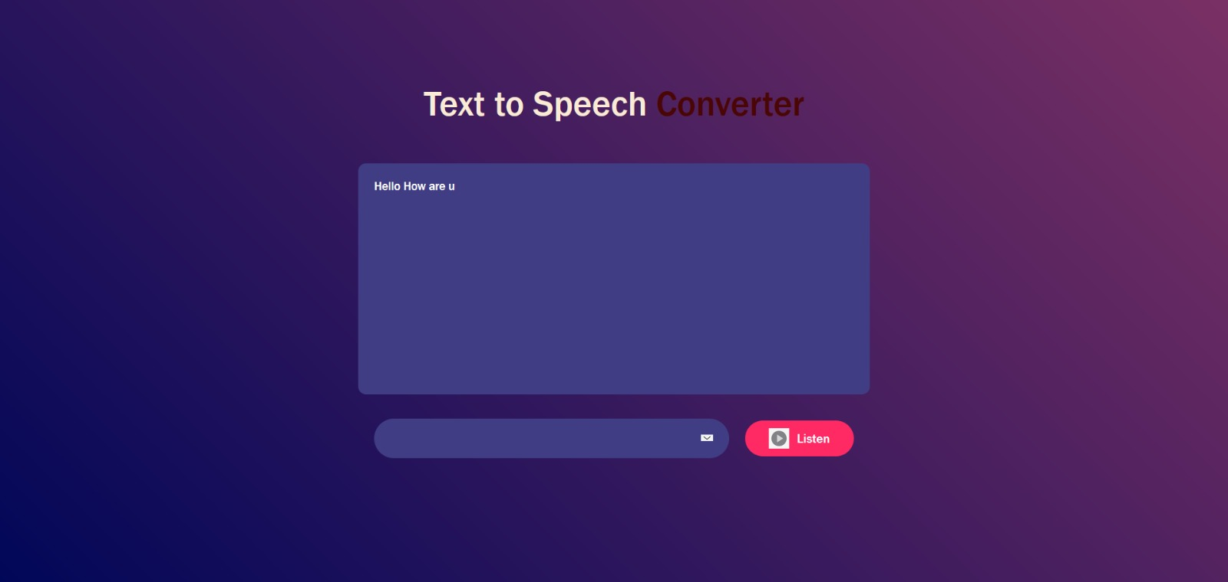 Fig 3.Text to Speech Coverter

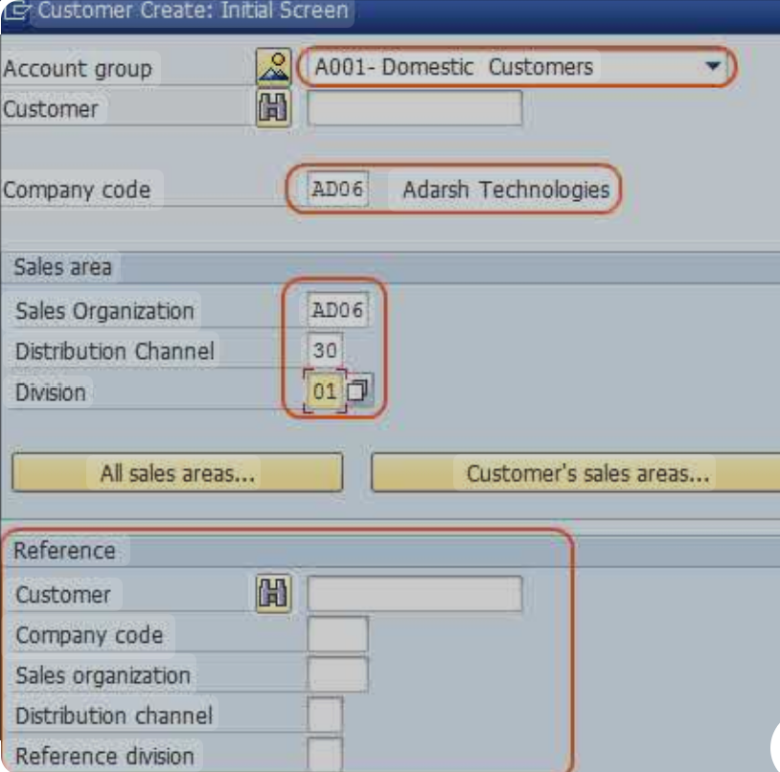

Fig 4. Customer Creation Image

21

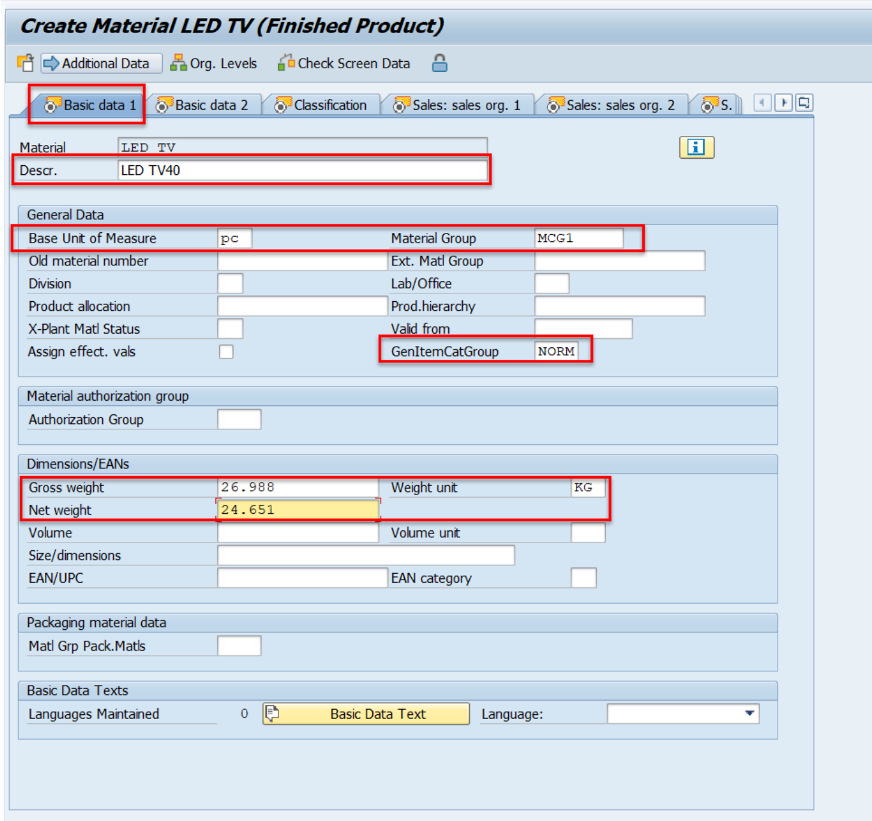

Fig 5. Material Creation Image

22